Monday 9th January 2023 – Lecture on Zoom, 7pm
Update from the Mammal Society!
Dr Frazer Coomber, Science Officer for the Mammal Society
Dr Frazer Coomber will give the Oxfordshire Mammal Group January Lecture on Zoom. Frazer last spoke to the Group a couple of years ago and this talk will provide an update on the numerous projects and survey results that the Mammal Society has been involved with or coordinated since then. As coordinator for the National Harvest Mouse Survey Frazer will provide results of the initial season and the status of the report and will also provide some updates on the current survey season. Further information on previous, ongoing, and upcoming surveys, such as the Volunteer Mountain Hare Survey and the national otter survey of England will also be provided. Moreover, Frazer aims to share the interesting finding of Greater white-toothed shrew records from mainland Britain and how people can get involved in helping to create baseline small mammal data and understand how widespread this species may be. If you would like to know how local mammal survey efforts fit into the national perspective and to know what the Mammal Society is currently working on and planning for the future this is the talk for you.

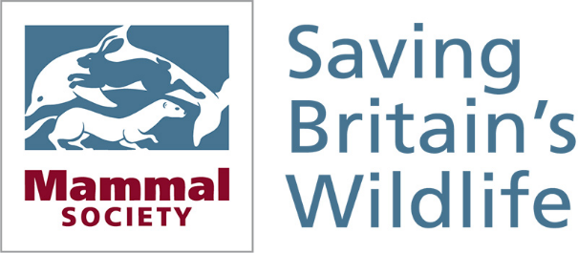

www.mammal.org.uk

