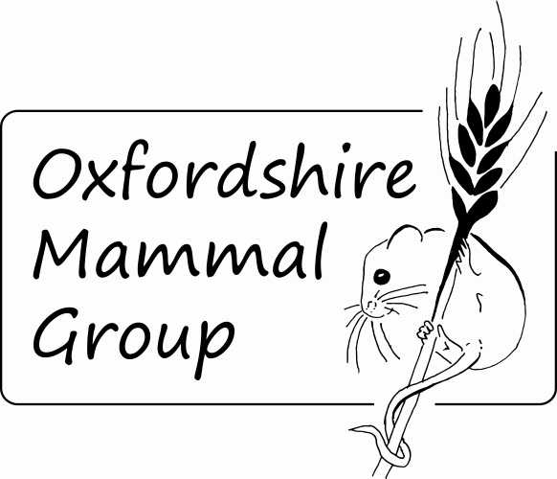
Membership Application
Form 2019

Title: First name:
Surname:
Address:

Postcode: Telephone number:
Email address:
This section is optional but will help Oxfordshire Mammal Group tailor events and activities to best suit the interests of the membership.
- Which description best describes your reason for becoming a member?
☐ No survey experience but interested in seeing/learning more about Oxfordshire’s
mammals
☐ Limited survey experience but would like to develop mammal recording skills
☐ Experienced in carrying out mammal surveys and looking to share knowledge and
records with others across the county
☐ Would you be interested in providing training sessions for less-experienced
members? (If yes, please provide details)

- Please list any mammal licenses you currently hold.

Membership type: (Please tick appropriate option. See note 2 overleaf)
☐ Single (£6) ☐ Family (£12)
☐ £1 discount per person off OxMG single and family memberships when paying by standing order.
For family memberships, please provide the name of the second adult at the same address:

Total payment: £ . I am paying by cheque / cash / standing order / bank transfer (see note 7 overleaf) (delete as appropriate)
I understand that Oxfordshire Mammal Group will:
- contact me (if I provide an email address) with information about activities, events, notices and membership information in accordance with the legitimate interests of Oxfordshire Mammal Group, The Mammal Society and me, as a member of Oxfordshire Mammal Group.
- not share my personal information with third-party organisations, without my explicit permission.
I confirm that I have read and understood the accompanying notes.
Signature: Date:
Oxfordshire Mammal Group Membership Application 2019
Accompanying Notes
- The membership year for 2019 expires end March 2020.
- Membership fees for the 2019/2020 membership year are as follow:
- £6 for single members
- £12 for a family (classed as 2 adults plus any children under 16 who are resident at the same address). Children must always be accompanied by a parent or guardian when taking part in group events or activities.
- A £1 discount per person is offered for members paying by standing order.
Oxfordshire Mammal Group is affiliated to The Mammal Society. However, membership of The Mammal Society and any of its groups such as the Oxfordshire Mammal Group are completely separate. To join The Mammal Society, please go to: www.mammal.org.uk
- All adult members must complete and sign a membership form. For family membership, both adults should each complete a membership form, submitting both forms with joint payment.
- If you provide an email address you will be invited to join Oxfordshire Mammal Group’s Google Groups emailing forum and be able to post to and receive messages from other members via this forum. You do not need to provide an email address to become a member, but if you do not you will not receive communication from the group.
- The Oxfordshire Mammal Group believes the security of any personal information we hold is extremely important. Membership data will be held on Google Docs with access restricted to committee members only. We will not use your data for any financial gain, as we seek only to inform and educate our members, as defined by our constitution. We endeavour to comply with the General Data Protection Regulation of May 2018.
- Membership of the Oxfordshire Mammal Group is conditional on the following:
  - That you shall agree to be responsible for your own actions and involvement and for the actions of any children under your care.
  - That you shall agree to abide by the constitution of the Oxfordshire Mammal Group, which is available upon request from the Secretary.
- Payment may be made by cheque or by cash (in person only) or by bank transfer. Cheques should be made payable to Oxfordshire Mammal Group and sent by post to the address in note 8. If you wish to pay by bank transfer or standing order, the details are as follow: Oxon Mammal Group, sort code:- 20-01-09, account number: 83446530. Please include your name as a reference when paying by bank transfer or standing order.
- Completed forms should either be sent by email to membership@oxonmammals.org.uk or by post to OxMG Membership C/O, 1 Chiltern View, Little Milton, Oxfordshire, OX44 7QP.

